Electrical Safety Program

Prepared by:
The Ohio State University
Environmental Health and Safety
Occupational Safety & Industrial Hygiene

1314 Kinnear Road
Columbus, OH 43212-1168

614-292-1284 Phone
614-292-6404 Fax

www.ehs.osu.edu

Table of Contents

Introduction 3
Responsibilities 3
Definitions 4
Training 5
Working On or Near Live Parts 6
Personal Protective Equipment 7
Insulated Tools and Equipment 9
Portable Power Tools and Extension Cords 9
Labeling 10
Alerting Techniques 10
Housekeeping 10
Contract Employees 10
Arc Flash Safety 11

Appendix A – Approach Boundaries to Live Parts for Shock Protection 12
Appendix B – Arc Flash Hazard Label 13

Appendix C – Protective Clothing and PPE 14

Appendix D – PPE for Common Electrical Work Tasks at OSU 15

- Introduction
  - Electricity is a serious workplace hazard, capable of causing both employee injury and property damage. It is the policy of The Ohio State University (OSU) to protect all employees, students, and other personnel from potential electrical hazards. This will be accomplished through compliance with the work practices described herein along with the effective application of engineering controls, administrative controls and the use of personal protective equipment (PPE). OSU seeks to put forth an organized effort to reduce the potential for injury.
  - The OSU Electrical Safety Program is founded on the principle of avoiding energized work unless it is absolutely necessary. Live parts will be de-energized before an employee works on or near them unless one of the following conditions apply:
    - De-energizing introduces additional or increased hazards. Examples of “additional or increased” hazards would include interruption of life support equipment, deactivation of emergency alarm systems or shutdown of hazardous location ventilation systems.
    - De-energizing is not possible due to equipment design or operational limitations. Examples of this situation would increase testing of electrical circuits that can only be performed with the circuit energized and work on circuits that form an integral part of a continuous process that would otherwise need to be completely shut down in order to permit work on one circuit or piece of equipment.
    - Live parts are operating at less than 50 volts to ground and there is no increased exposure to electrical burns or to explosion due to electrical arcs.
  - Live parts are to be de-energized in accordance with Departmental Control of Hazardous Energy (Lockout/Tagout) policies. If live parts are not placed in an electrically safe condition, the work practices described in this program must be used to protect employees.
- Responsibilities
  - The Office of Environmental Health and Safety
    - EH&S shall ensure the Electric Safety Program is reviewed, maintained and updated.
    - EH&S will, if necessary, provide recommendations for additional control methods to be used in areas where deemed necessary to protect employees from electrical hazards.
  - Supervisors
    - Determine the applicability of this program to applied activities within their respective areas.
    - Coordinate the implementation of the electrical safety program within their areas.
    - Ensure employees comply with all provisions of this program.
    - Ensure employees receive training appropriate to their assigned electrical tasks and maintain documentation of such training.
    - Ensure employees are provided with and use appropriate PPE.
  - Electricians
    - Assist shops in implementing the provisions of this program.
    - Provide or assist in task specific training for electrical work qualifications.
    - Evaluate overall effectiveness of the OSU electrical safety program.
  - Employees
    - Follow the work practices described in this program, including the use of appropriate protective equipment and tools.
    - Do not perform tasks unless the proper training has been provided.
    - Attend all training required relative to this program.
    - Report any concerns related to electrical safety to supervision.
- Definitions
Arc Flash - a phenomenon where a flashover of electric current leaves its intended path and travels through the air from one conductor to another, or to the ground.
Arc Rating – the maximum incident energy resistance demonstrated by a material (or a layered system of materials) prior to “breaking open” or at the onset of a second-degree skin burn. This rating is assigned to electrical protective clothing and is normally expressed in calories per square centimeter (cal/cm²).
De-energized – free from any electrical connection to a source of potential difference and from electric charge.
Electrically safe working condition – a state in which the conductor or circuit part to be worked on or near has been disconnected from energized parts, locked/tagged in accordance with OSU policy, tested to ensure the absence of voltage, and grounded if determined necessary.
Energized – electrically connected to or having a source of voltage.
Exposed (as to live parts) – capable of being inadvertently touched or approached from closer than a safe distance by a person.
Flash Hazard – a dangerous condition associated with the release of energy caused by an electric arc.
Flash Hazard Analysis – a study investigating a worker’s potential exposure to arc flash energy, conducted for the purpose of injury prevention, the determination of safe work practices, and the appropriate levels of personal protective equipment (PPE).
Flash Protection Boundary – an approach limit at a distance from exposed live parts within which a person could receive a second degree burn if an electrical arc were to occur.
Flame-Resistant (FR) – the property of a material whereby combustion is prevented, terminated, or inhibited following the application of a flaming or non-flaming source of ignition, with or without subsequent removal of the ignition source.
Flash Suit – a complete flame-resistant clothing and equipment system that covers the entire body, except for the hands and feet.
Incident Energy – the amount of energy impressed on a surface, a certain distance from the source, generated during an electrical arc event.
Limited Approach Boundary – an approach limit at a distance from an exposed live part within which a shock hazard exists.
Prohibited Approach Boundary – an approach limit at a distance from an exposed live part within which work is considered the same as making direct contact with the live part.
Qualified person – one who has skills and knowledge related to the construction and operation of the electrical equipment and installation and has received training on the hazards involved.
Restricted Approach Boundary – an approach limit at a distance from an exposed live part within which there is an increased risk of shock, due to electrical arc over combined with inadvertent movement, for personnel working in close proximity to the live part.
- Training
  - Employees who are exposed to an electrical hazard that is not reduced to a safe level by the installation (panel cover, outlet cover, etc.) must be trained.
  - Training must be provided before the employee is assigned duties that involve work near or on electrical systems.
  - The level of electrical safety training provided is dependent on whether the employee is classified as a “qualified” or “unqualified” person.
  - A “qualified person” shall be trained and knowledgeable in all of the following topics:
    - Construction and operation of equipment on which work is assigned.
    - Skills and techniques necessary to distinguish exposed energized parts from other parts of electrical equipment.
    - Skills and techniques necessary to determine the nominal voltage of exposed live parts or the absence of voltage.
      - An individual can obtain knowledge in the three topics listed above through a combination of methods including the individual’s education, past work experience, apprenticeships, and on-the-job training.
    - The approach distances specified in this program and the corresponding voltages to which the qualified employee will be exposed.
    - The process necessary to determine the degree and extent of electrical hazards along with the PPE and job planning necessary to perform the task safely.
  - A person can be considered qualified with respect to certain equipment and methods but unqualified for others.
  - An “unqualified person” shall be trained in the inherent hazards of electricity and any related work practices that are necessary for their safety. This training is considered an awareness level of training.
  - Supervisors shall maintain a record of all electrical training provided to their employees along with a listing of all employees classified as qualified persons.
- Working On or Near Live Parts
  - Job Briefing
    - A job briefing is required before the start of each job involving energized electrical work. Each qualified person shall be briefed on the job. At a minimum the briefing must include the following: associated electrical hazards, work procedures, special precautions, isolation points and procedures, emergency response, PPE requirements and other work in the immediate area.
  - Approach Boundaries to Live Parts
    - Safe approach distances will be determined for all tasks in which approaching personnel are exposed to live parts.
    - Safe approach distances to fixed live parts can be determined by referring to Appendix A, “Approach Boundaries to Live Parts for Shock Protection.” This appendix can be used to identify the Limited, Restricted, and Prohibited Approach Boundaries associated with various system voltages.
    - Unqualified persons may only cross the Limited Approach Boundary when they are under the direct supervision of a qualified person.
    - Qualified persons may not cross or take any conductive objects closer than the Restricted Approach Boundary unless one of the following conditions applies:
      - The qualified person is insulated or guarded from the live parts and no uninsulated part of the qualified person’s body crosses the Prohibited Approach Boundary.
      - The live parts are insulated from the qualified person and from any other conductive object at a different potential.
    - Crossing the Prohibited Approach Boundary is considered the same as making contact with energized parts. Qualified persons may only cross this boundary when all of the following precautions have been taken:
      - The qualified person has specific training to work on energized parts.
      - The qualified person uses PPE appropriate for working on energized parts which is rated for the voltage and energy level involved.
  - Other Precautions for Personnel Activities
    - Employees shall not reach blindly into areas that might contain exposed live parts or above eye level where a panel may have an open knock out hole.
    - Employees shall not enter spaces containing live parts unless illumination is provided that allows the work to be performed safely.
    - Conductive articles of jewelry and clothing (such as watchbands, bracelets, rings, key chains, necklaces, metalized aprons, cloth with conductive thread, metal headgear, or metal frame glasses) shall not be worn where they present an electrical contact hazard with exposed live parts.
    - Conductive materials, tools, and equipment that are in contact with any part of an employee’s body shall be handled in a manner that prevents accidental contact with live parts. Such materials and equipment include, but are not limited to, long conductive objects such as ducts, pipes, tubes, conductive hose and rope, metal-lined rules and scales, steel tapes, pulling lines, metal scaffold parts, structural members, and chains.
    - When an employee works in a confined or enclosed space (such as a manhole or vault) that contains exposed live parts, the employee shall use protective shields, barriers or insulating materials as necessary to avoid contact with these parts. Doors, hinged panels, and the like shall be secured to prevent them from swinging into employees.
- Personal Protective Equipment (PPE)
  - General Requirements
    - Employees working in areas where electrical hazards are present shall be provided with, and shall use, protective equipment that is designed and constructed for the specific body part to be protected and for the work to be performed.
    - Department supervisors are responsible for providing electrical protective equipment required by this program at no cost to employees, such as flame resistant (FR) apparel, eye protection, head protection, hand protection, insulated footwear and face shields. Department supervisors are not responsible for providing non-FR under layers to employees.
    - All PPE shall be maintained in safe, reliable condition by the employee to whom it is issued.
    - Employee shall wear nonconductive head protection whenever there is a danger of head injury for electric shock or burns due to contact with live parts or from flying objects resulting from electrical explosion.
    - Employees shall wear PPE for the eyes whenever there is a danger of injury from electric arcs, flashes, or from flying objects resulting from electrical explosion.
    - Employees shall wear rubber insulating gloves where there is danger of hand and arm injury due to contact with live parts or possible exposure to arc flash burn. The following PPE ratings can be found on voltage rated gloves:
      - Class 00 = Protect against voltage up to 500 volts
      - Class 0 = Protect against voltage up to 1,000 volts
      - Class 1 = Protect against voltage up to 7,500 volts
      - Class 2 = Protect against voltage up to 17,000 volts
      - Class 3 = Protect against voltage up to 26,500 volts
      - Class 4 = Protect against voltage up to 36,000 volts
    - Where insulated footwear is used as protection against step and touch potential, dielectric overshoes, as illustrated below, shall be required. Insulated footwear shall not be used as the primary protection.
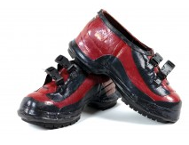 | 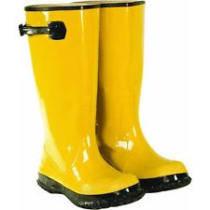

    - Face shields used during any electrical work must be arc rated to ensure adequate protection. Safety glasses or goggles must always be worn underneath face shields.
    - Additional illumination may be needed when using tinted face shields as protection during electrical work.
    - Employees shall wear hearing protection whenever there is a danger of noise overexposure resulting from an electrical explosion.
  - Flash Hazard Boundary
    - PPE shall be provided to and used by all employees working within the Flash Hazard Boundary.
    - The Flash Hazard Boundary is determined through a detailed arc flash hazard analysis.
    - This information can be located on the Arc Flash Hazard labels.
      - See Appendix B for an example of an Arc Flash Hazard label.
    - The specific PPE to be worn within the Flash Protection Boundary can be determined by one of following three methods:
      - Required PPE is listed on the Arc Flash Hazard labels.
      - A detailed description of necessary PPE is located in Appendix C, Protective Clothing and PPE.
      - Refer to Appendix D of this program to determine the necessary PPE for a given task. This appendix defines the PPE requirements for common electrical tasks based on the information contained in Appendices B and C.
  - Flame-Resistant Apparel & Under Layers
    - FR apparel shall be visually inspected before each use. FR apparel that is damaged or contaminated shall not be used. Protective items that become contaminated with grease, oil, flammable liquids or combustible liquids shall not be used.
    - The garment manufacturer’s instructions for care and maintenance of FR apparel shall be followed.
    - When FR apparel is worn to protect an employee, it shall cover all ignitable clothing and allow for movement and visibility.
    - FR apparel must cover potentially exposed areas as completely as possible. FR shirt sleeves must be fastened and FR shirts/jackets must be closed at the neck.
    - Non-melting, flammable garments (i.e. cotton, wool, rayon, silk, or blends of these materials) may be used as under layers beneath FR apparel.
    - Fibers that can melt such as acetate, nylon, polyester, polypropylene, and spandex shall not be permitted in fabric under layers next to the skin.
    - When FR apparel is required, garments worn as outer layers over FR apparel (i.e. jackets or raingear) must also be made from FR material.
    - Flash suits must permit easy and rapid removal by the user.
- Insulated Tools and Equipment
  - Only insulated tools and equipment shall be used within the Limited Approach Boundary of exposed energized parts.
  - Insulated tools shall be rated for the voltages on which they are used.
  - Insulated tools shall be designed and constructed for the environment to which they are exposed and the manner in which they are used.
  - Fuse of fuse holder handling equipment, insulated for the circuit voltage, shall be used to remove or install a fuse if the fuse terminals are energized.
  - Ropes and hand lines used near exposed energized parts shall be nonconductive.
  - Portable ladders used for electrical work shall have nonconductive side rails.
- Portable Power Tools and Extension Cords
  - Electrically powered portable hand tools shall be protected by a grounding conductor. The metal parts of portable and/or plug connected equipment shall be protected through three (3) wire cords and plugs.
  - GFCI protection is also required when cord sets, power tools, etc., are connected to permanent wiring.
  - GFCI is required with all extension cords. Cords shall be protected from sharp edges and corners. Cords shall not be spliced or taped.
  - Extension cords and cables passing through the work area shall be elevated or covered for protection, and arranged to eliminate any tripping hazards. All cords should be checked for proper polarity.
  - Extension cords must be three (3) wire, 14 gauge or heavier with a ground plug.
  - Damaged or worn cords must be taken out of service and tagged defective and repaired or removed.
  - Extension cords may not be used as a permanent source of power.
- Labeling
  - All switchboards, panel boards, industrial panels, motor control centers, and meter socket enclosures shall be labeled using a label similar to the one found in Appendix B.
  - Circuit breakers should be labeled as to what each circuit controls.
- Alerting Techniques
  - Barricades shall be used in conjunction with safety signs to prevent or limit access to work areas containing live parts. Conductive barricades shall not be used where they might cause an electrical hazard. Barricades shall be placed no closer than the Limited Approach Boundary.
  - If signs and barricades do not provide sufficient protection, an attendant will be assigned to warn and protect pedestrians. The primary duty of the attendant shall be to keep unqualified persons out of the work area where an electrical hazard exists. The attendant shall remain in the area as long as there is a potential exposure to electrical hazards.
- Housekeeping
  - Good housekeeping must be maintained at all times. Poor housekeeping in mechanical spaces presents many hazards including fire, trip and accidental contact; as well as code violations.
    - The OSHA Standard (29 CFR 1910.303 (g)) requires sufficient access and working space around all equipment serving 600 volts or less. For equipment serving between 120 and 250 volts, the regulations require a minimum of three feet of clearance. The width of the working space in front shall be 30 inches minimum or width of the equipment.
    - The National Electric Code (NFPA 70 110.26) requires a minimum of 36 inches of clear working space in the direction of any access to live parts.
- Contract Employees
  - Contractors are responsible for following the OSU Electrical Safety program, as well as the contractor’s in house policy.
  - OSU shall inform contractors engaged in electrical work of any known hazards applicable to the work being performed. Contractors are required to follow all applicable OSHA regulations and NFPA 70E standards.
  - All proper PPE must be used and is to be provided by the contractor.
- Arc Flash Safety
  - It is the goal of the Ohio State University to control the arc flash hazard, which occurs during the maintenance of electrical building components throughout all facilities. To reduce the potential for arc flash incidences, the following procedures should be followed:
    - De-energize all circuits before performing work on them (follow departmental policies when de-energizing circuits).
    - Ensure that all possible sources of supply are found and open disconnecting devices for each source.
    - Apply Lockout/Tagout devices in accordance with Departmental Lockout/Tagout Policies.
    - Test voltage on each conductor to verify that it is de-energized.
    - Apply grounding devices where stored energy or induced voltage could exist or where de-energized conductors could contact live parts.
  - If work is necessary on energized parts, the following procedures should be followed:
    - Establish boundaries keeping those not involved with the work ten (10) feet away.
    - Use insulated tools along with considering insulated floor mats.
    - Wear safety glasses/goggles and voltage rated gloves.
    - Wear hard-soled leather work shoes or dielectric overshoes.
    - Wear appropriate arc flash protection.
      - Voltages 50-120 = standard cotton shirt and cotton pants.
      - Voltages 120-600 = category 2 arc flash coat over standard uniform, low voltage gloves, hardhat with arc flash shield and earplugs.
Appendix A – Approach Boundaries to Live Parts for Shock Protection
All dimensions are distance from live part to employee.
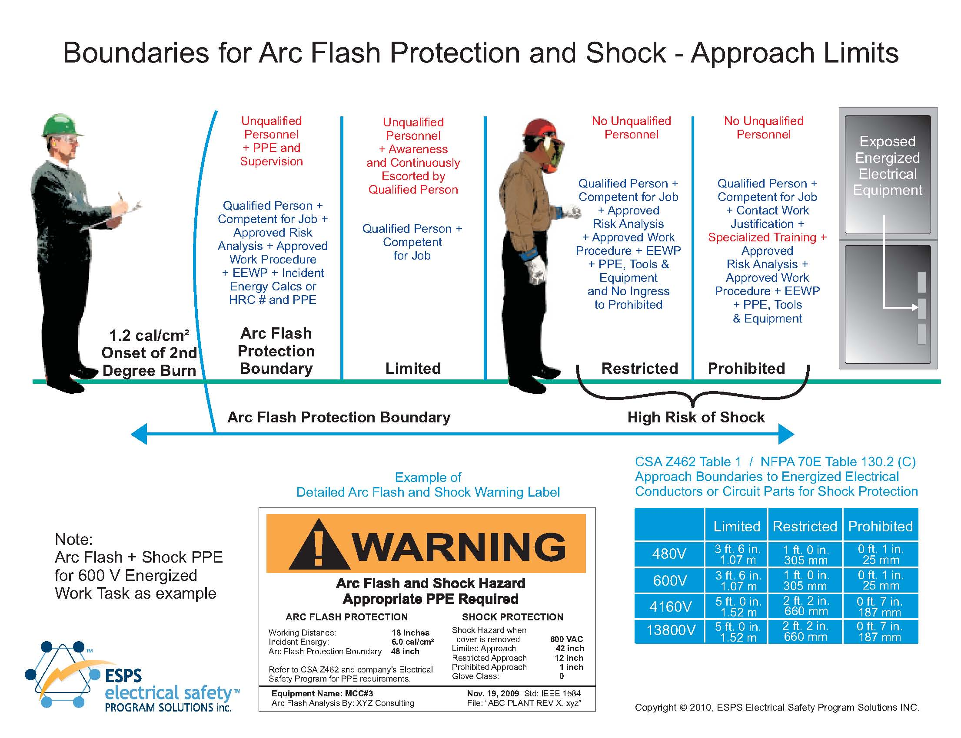
Appendix B- Arc Flash Hazard Label
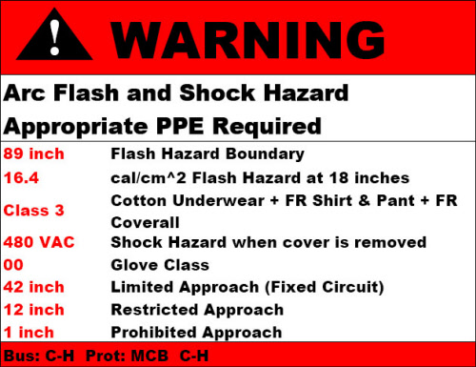
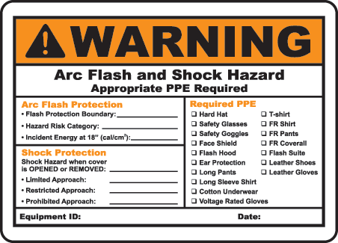
Appendix C – Protective Clothing and PPE
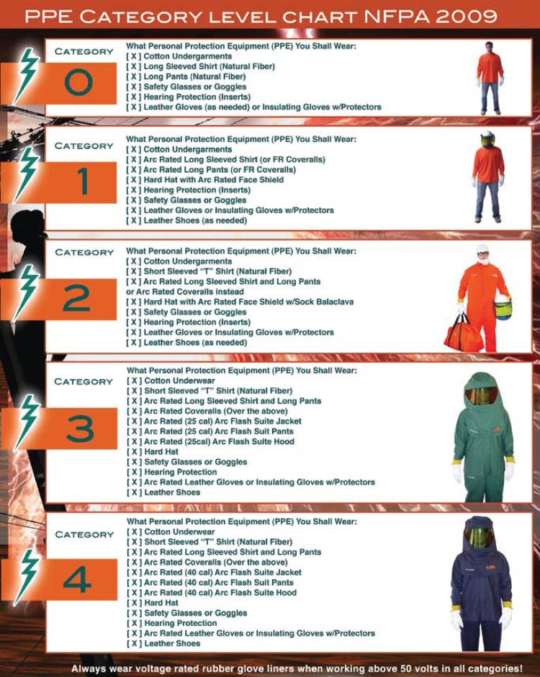
Appendix D – PPE for Common Electrical Work Tasks at OSU

Panelboards or other equipment rated 240V and below
Job tasks performed on energized equipment | Protective Requirements
Perform infrared thermography and other non-contact inspections outside the restricted approach boundary. (hazard/risk category 0) | Non-melting or untreated natural fiber:  - Long sleeve shirt  - Long pants  PPE:  - Safety glasses or goggles  - Leather gloves (as needed)
Circuit breaker or fused switch operation with covers on. (hazard/risk category 0) | Non-melting or untreated natural fiber:  - Long sleeve shirt  - Long pants  PPE:  - Safety glasses or goggles  - Leather gloves (as needed)
Circuit breaker or fused switch operation with covers off. (hazard/risk category 0) | Non-melting or untreated natural fiber:  - Long sleeve shirt  - Long pants  PPE:  - Safety glasses or goggles  - Leather gloves (as needed)
Removal of bolted covers (to expose bare, energized electrical conductors and circuit parts). (hazard/risk category 0) | FR Clothing, minimum arc rating of 4:  - Long sleeve shirt and long pants (Cal rating of 4)  - OR Coveralls (Cal rating of 4)  - Face-shield or flash suit hood (Cal rating of 4)  - Jacket, parka, or rainwear (as needed based on conditions)  PPE:  - Hardhat  - Safety glasses or goggles  - Leather gloves

Panelboards or other equipment rated 240V and below
Job tasks performed on energized equipment | Protective Requirements
Work on energized electrical conductors and circuit parts, including voltage testing and troubleshooting. (hazard/risk category 1) | FR Clothing, minimum arc rating of 4:  - Long sleeve shirt and long pants (Cal rating of 4)  - OR Coveralls (Cal rating of 4)  - Face-shield or flash suit hood (Cal rating of 4)  - Jacket, parka, or rainwear (as needed based on conditions)  PPE:  - Safety glasses or goggles  - Rubber insulating gloves  - Leather gloves
Remove or install circuit breakers or fused switches. (hazard/risk category 1) | FR Clothing, minimum arc rating of 4:  - Long sleeve shirt and long pants (Cal rating of 4)  - OR Coveralls (Cal rating of 4)  - Face-shield or flash suit hood (Cal rating of 4)  - Jacket, parka, or rainwear (as needed based on conditions)  PPE:  - Safety glasses or goggles  - Rubber insulating gloves  - Leather gloves
Opening hinged covers (to expose bare, energized electrical conductors and circuit parts). (hazard/risk category 1) | Non-melting or untreated natural fiber:  - Shirt (long sleeve)  - Pants (long)  PPE:  - Safety glasses or goggles  - Leather gloves (as needed)
Work on energized electrical conductors and circuit parts of utilization equipment fed directly by branch circuit of the panelboard. (hazard/risk category 1) | FR Clothing, minimum arc rating of 4:  - Long sleeve shirt and long pants (Cal rating of 4)  - OR Coveralls (Cal rating of 4)  - Face-shield or flash suit hood (Cal rating of 4)  PPE:  - Safety glasses or goggles  - Rubber insulating gloves  - Leather gloves

Panelboards or Switchboards Rated greater than 240 V and up to 600 V (with molded case or insulated case circuit breakers)
Job tasks performed on energized equipment | Protective Requirements
Perform infrared thermography and other non-contact inspections outside the restricted approach boundary. (hazard/risk category 1) | FR Clothing, minimum arc rating of 4:  - Long sleeve shirt and long pants (Cal rating of 4)  - OR Coveralls (Cal rating of 4)  - Face-shield or flash suit hood (Cal rating of 4)  - Jacket, parka, or rainwear (as needed based on conditions)  PPE:  - Safety glasses or goggles  - Rubber insulating gloves  - Leather gloves (as needed)
Circuit or fused switch operation with covers on. (hazard/risk category 0) | Non-melting or untreated natural fiber:  - Shirt (long sleeve)  - Pants (long)  PPE:  - Safety glasses or goggles  - Leather gloves (as needed)
Circuit breaker or fused switch operation with covers off. (hazard/risk category 1) | FR Clothing, minimum arc rating of 4:  - Long sleeve shirt and long pants (Cal rating of 4)  - OR Coveralls (Cal rating of 4)  - Face-shield or flash suit hood (Cal rating of 4)  - Jacket, parka, or rainwear (as needed based on conditions)  PPE:  - Safety glasses or goggles  - Rubber insulating gloves  - Leather gloves  - Leather work shoes (as needed)

Panelboards or Switchboards Rated greater than 240 V and up to 600 V (with molded case or insulated case circuit breakers)
Job tasks performed on energized equipment | Protective Requirements
Work on energized electrical conductors and circuit parts, including voltage testing and troubleshooting. (hazard/risk category 2*) | FR Clothing, minimum arc rating of 4:  - Long sleeve shirt and long pants (Cal rating of 8)  - OR Coveralls (Cal rating of 8)  - OR Face-shield (Cal rating of 8) and Balaclava (Cal rating of 8)  - Jacket, parka, or rainwear (as needed based on conditions)  PPE:  - Safety glasses or goggles  - Rubber insulating gloves  - Leather gloves  - Leather work shoes
Work on energized electrical conductors and circuit parts of utilization equipment fed directly by a branch circuit of the panelboard or switch. (hazard/risk category 2*) | FR Clothing, minimum arc rating of 4:  - Long sleeve shirt and long pants (Cal rating of 8)  - OR Coveralls (Cal rating of 8)  - OR Face-shield (Cal rating of 8) and Balaclava (Cal rating of 8)  - Jacket, parka, or rainwear (as needed based on conditions)  PPE:  - Safety glasses or goggles  - Rubber insulating gloves  - Leather gloves  - Leather work shoes

Other 600 V Class (277 V through 600 V, nominal) Equipment
Job tasks performed on energized equipment | Protective Requirements
Lighting or small power transformers (600 V, maximum)
Removal of bolted covers (to expose bare, energized electrical conductors and circuit parts) (hazard/risk category 2*) | FR Clothing, minimum arc rating of 8:  - Long sleeve shirt and long pants (Cal rating of 8)  - OR Coveralls (Cal rating of 8)  - OR Face-shield (Cal rating of 8) and Balaclava (Cal rating of 8)  - Jacket, parka, or rainwear (as needed based on conditions)  PPE:  - Safety glasses or goggles  - Leather gloves  - Leather work shoes
Opening hinged covers (to expose bare, energized electrical conductors and circuit parts) (hazard/risk category 1) | FR Clothing, minimum arc rating of 4:  - Long sleeve shirt and long pants (Cal rating of 4)  - OR Coveralls (Cal rating of 4)  - Face-shield or flash suit hood (Cal rating of 4)  - Jacket, parka, or rainwear (as needed based on conditions)  PPE:  - Safety glasses or goggles  - Leather gloves  - Leather work shoes (as needed)

Other 600 V Class (277 V through 600 V, nominal) Equipment
Job tasks performed on energized equipment | Protective Requirements
Work on energized electrical conductors and circuit parts, including voltage testing. (hazard/risk category 2*) | FR Clothing, minimum arc rating of 8:  - Long sleeve shirt and long pants (Cal rating of 8)  - OR Coveralls (Cal rating of 8)  - OR Face-shield (Cal rating of 8) and Balaclava (Cal rating of 8)  - Jacket, parka, or rainwear (as needed based on conditions)  PPE:  - Safety glasses or goggles  - Rubber insulating gloves  - Leather gloves  - Leather work shoes
Application of safety grounds, after voltage testing (hazard/risk category 2*) | FR Clothing, minimum arc rating of 8:  - Long sleeve shirt and long pants (Cal rating of 8)  - OR Coveralls (Cal rating of 8)  - OR Face-shield (Cal rating of 8) and Balaclava (Cal rating of 8)  - Jacket, parka, or rainwear (as needed based on conditions)  PPE:  - Safety glasses or goggles  - Rubber insulating gloves  - Leather gloves  Leather work shoes

